Handwritten Digit Recognition
A Machine Learning Project Report
Fundamentals of AI and Machine Learning
Submitted by: Anokhi shrivastav
Registration no. : 25MIB10061
Date: 18 September 2026
GitHub Repository: github.com/prabuddhsharma7/HANDWRITTEN-DIGIT-RECOGNITION

1. Introduction
Handwritten digit recognition is a classic and widely studied problem in the fields of Artificial Intelligence (AI) and Machine Learning (ML). It involves teaching a computer to correctly identify a numeric digit (0-9) from an image of handwriting, a task humans perform intuitively but which requires a model to learn patterns from pixel data. This project was built as a hands-on demonstration of core AI/ML fundamentals: loading and preparing data, training models, evaluating their performance, and drawing conclusions from the results.
Two classification approaches were implemented and compared: a Support Vector Machine (SVM), a classical and highly effective ML algorithm, and a Multi-Layer Perceptron (MLP), a simple feedforward neural network. Comparing these two highlights the difference between traditional machine learning and neural network-based approaches on the same task.

2. Objective
The goals of this project were to:
- Understand and apply the standard machine learning workflow: data loading, preprocessing, train/test splitting, model training, and evaluation.
- Implement and compare two different classification algorithms on the same dataset.
- Evaluate model performance using appropriate metrics (accuracy, precision, recall, F1-score, confusion matrix).
- Visualize both the raw data and the model's predictions for interpretability.
- Build a clean, reproducible project suitable for sharing as an open-source GitHub repository.

3. Dataset
The project uses the Digits dataset built into scikit-learn, a well-known toy dataset for classification tasks. It consists of 1,797 grayscale images of handwritten digits, each 8x8 pixels in size (64 features when flattened). Because this dataset ships with scikit-learn, no external download is required, making the project easy to set up and run.
Attribute | Value
Dataset | scikit-learn load_digits
Total samples | 1,797 images
Image size | 8 x 8 pixels (64 features per image)
Classes | 10 (digits 0-9)
Training samples | 1,437 (80%)
Test samples | 360 (20%)
Split method | Stratified train/test split
Table 1: Summary of dataset characteristics
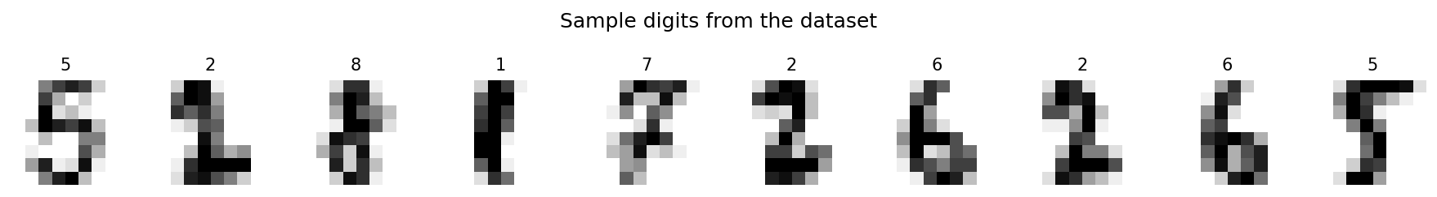
Figure 1: Sample handwritten digits from the dataset

4. Methodology

4.1 Data Preparation
The dataset was split into training (80%) and testing (20%) subsets using a stratified split, ensuring each digit class was proportionally represented in both sets. This prevents bias toward any particular digit and gives a fair evaluation of model performance.

4.2 Models Used
Two models were trained on the same training data and evaluated on the same held-out test set:
- Support Vector Machine (SVM): Used an RBF (Radial Basis Function) kernel, which is effective at capturing non-linear relationships between pixel intensities and digit classes.
- Multi-Layer Perceptron (MLP): A simple neural network with two hidden layers (64 and 32 neurons) using ReLU activation, trained with up to 500 iterations.

4.3 Evaluation Metrics
Both models were evaluated using accuracy, precision, recall, and F1-score (via a classification report), as well as a confusion matrix to visualize which digits were most often confused with one another.

4.4 Tools and Libraries
- Python 3 — programming language
- scikit-learn — dataset, models, evaluation metrics
- Matplotlib — data and result visualization
- NumPy — numerical operations
- joblib — saving and loading the trained model

5. Results
Both models were trained and evaluated on an identical 360-image test set. The results are summarized below:
Model | Test Accuracy | Training Time
SVM (RBF kernel) | 99.17% | ~0.03 s
Neural Network (MLP) | 96.67% | ~0.55 s
Table 2: Model comparison on the test set
The SVM classifier outperformed the neural network, achieving 99.17% accuracy compared to 96.67% for the MLP, while also training substantially faster. This is a reasonable outcome given the small, low-dimensional, and relatively clean nature of the dataset — SVMs are known to perform very well on datasets of this size and structure. The SVM was therefore selected as the final model and saved for reuse.
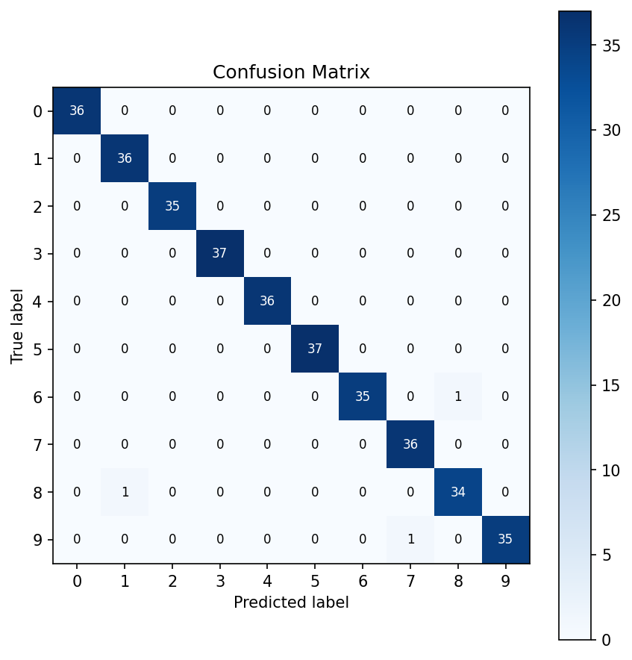
Figure 2: Confusion matrix for the SVM model on the test set
The confusion matrix shows a near-perfect diagonal, indicating the model correctly classified almost every digit. Out of 360 test images, only 2 were misclassified — one '6' predicted as '8', and one '9' predicted as '7' — both plausible confusions given how visually similar these digit pairs can be in handwriting.
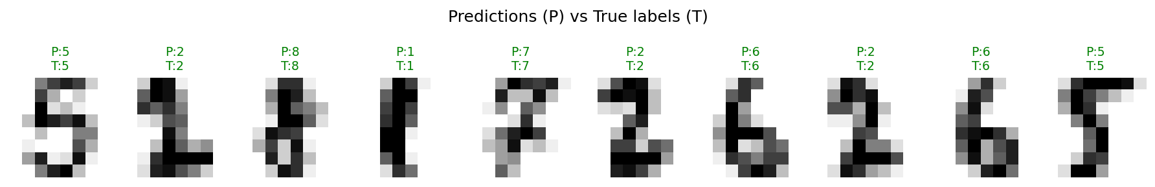
Figure 3: Sample predictions from the SVM model (P = Predicted, T = True label)

6. Conclusion
This project successfully demonstrates the fundamental workflow of a machine learning classification task, from raw data to a trained, evaluated, and saved model. The comparison between a classical algorithm (SVM) and a simple neural network (MLP) showed that, for a small and well-structured dataset like this one, a properly tuned SVM can match or exceed the performance of a basic neural network while training significantly faster. This reinforces an important AI/ML fundamental: model choice should be guided by the nature and scale of the data, not by complexity for its own sake.
The final SVM model achieved 99.17% test accuracy, making it highly reliable for this task. The project is structured as a clean, reproducible GitHub repository with clear documentation, making it suitable as a learning reference or a portfolio piece.

7. Future Scope
- Extend the project to the full MNIST dataset (28x28 pixels, 70,000 images) for a larger-scale challenge.
- Implement a Convolutional Neural Network (CNN) using PyTorch or TensorFlow to explore deep learning approaches.
- Add hyperparameter tuning (e.g., GridSearchCV) to further optimize model performance.
- Build an interactive web interface (e.g., using Streamlit) allowing users to draw a digit and get a live prediction.

8. References
1. scikit-learn documentation — Optical Recognition of Handwritten Digits Dataset. https://scikit-learn.org/stable/datasets/toy_dataset.html
2. scikit-learn documentation — Support Vector Machines. https://scikit-learn.org/stable/modules/svm.html
3. scikit-learn documentation — Neural network models (supervised). https://scikit-learn.org/stable/modules/neural_networks_supervised.html

